TABLES for cable report

2018-04-16

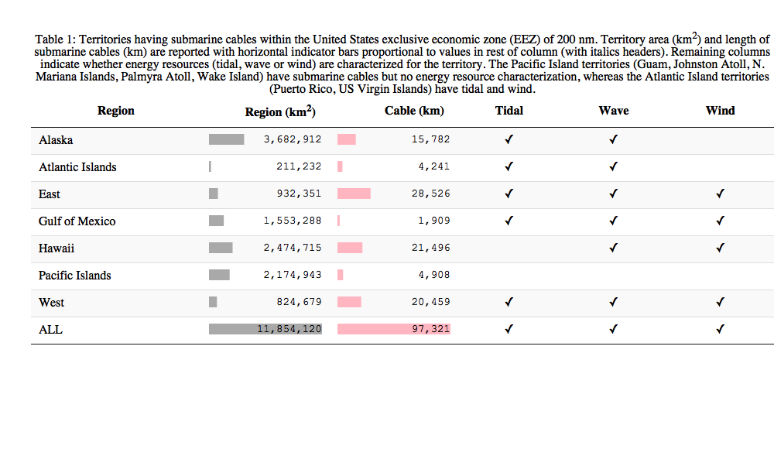

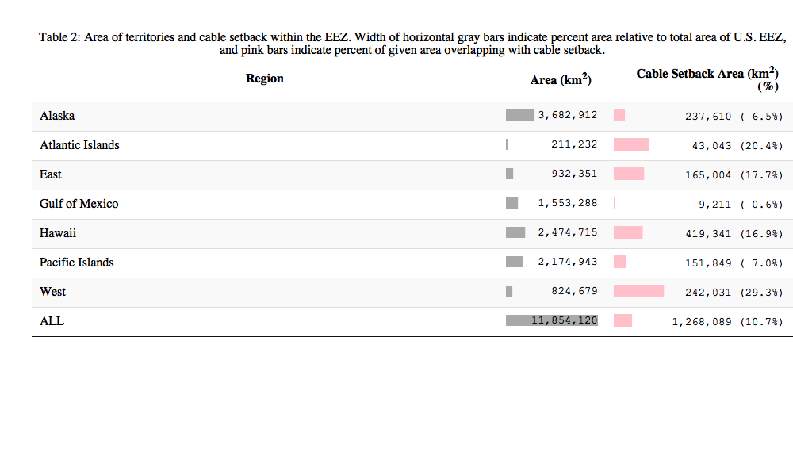

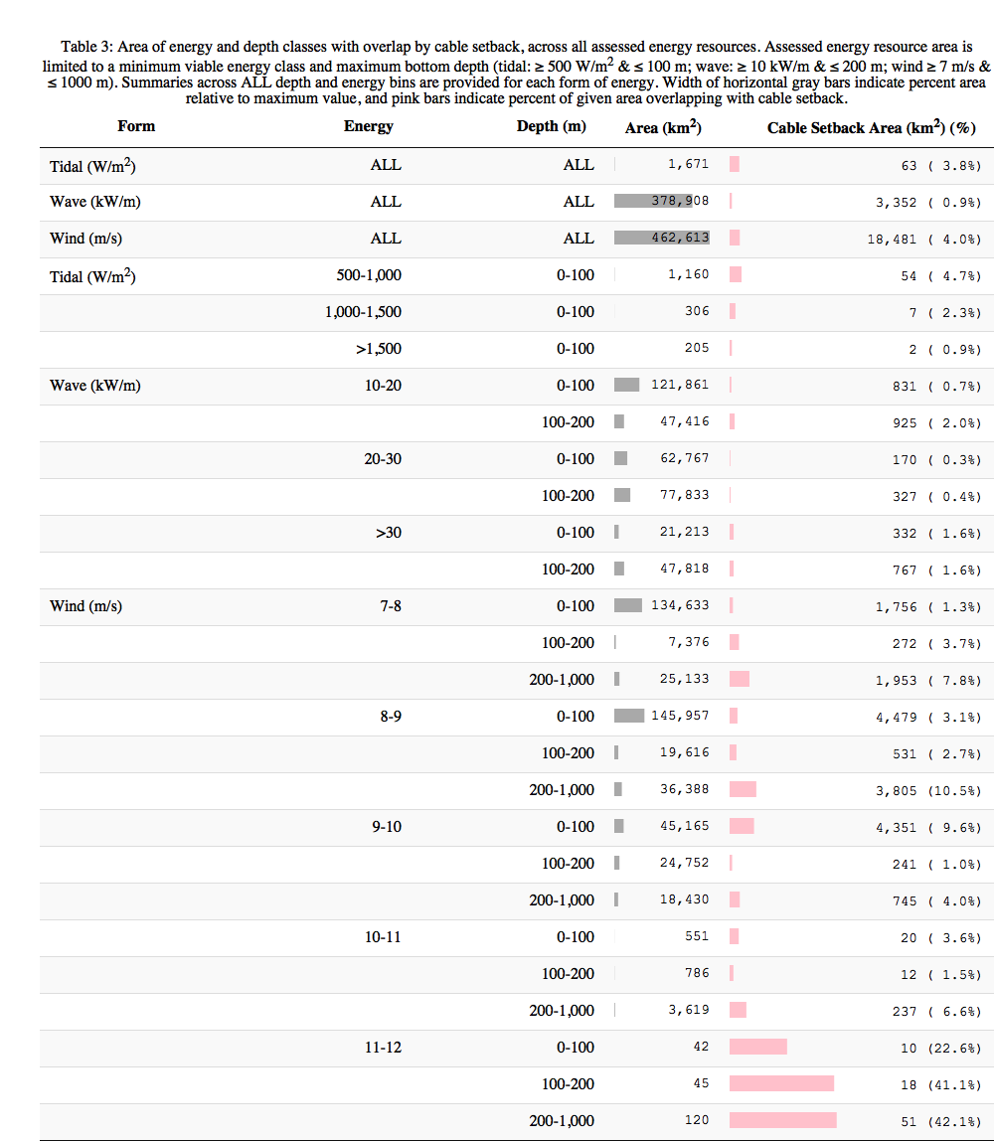

(#tab:tbl04Tide_3z)Table 4: Area of tidal power classes (W/m2) per region and overlap with cable setback. Assessed area, including ALL for region, is limited to a maximum depth (≤ 100 m) and minimum energy (≥ 500 W/m2) for viable tidal energy development. The Atlantic Islands (Puerto Rico, US Virgin Islands) only contained the lowest tidal energy class (< 500 W/m2) within the prescribed area so do not show up in this table despite having tidal energy resource characterized. Width of horizontal gray bars indicate percent area relative to maximum value, and pink bars indicate percent of given area overlapping with cable setback.

|  |  |  |  |
| --- | --- | --- | --- |
| Region | Tidal power (W/m2) | Area (km2) | Cable Setback  Area (km2) (%) |
| Alaska | ALL | 955 | 41 ( 4.3%) |
|  | 500-1,000 | 691 | 33 ( 4.8%) |
|  | 1,000-1,500 | 162 | 5 ( 3.3%) |
|  | >1,500 | 101 | 2 ( 1.8%) |
| East | ALL | 604 | 8 ( 1.3%) |
|  | 500-1,000 | 390 | 6 ( 1.7%) |
|  | 1,000-1,500 | 127 | 2 ( 1.3%) |
|  | >1,500 | 87 | 0 ( 0.0%) |
| Gulf of Mexico | ALL | 43 | 0 ( 0.0%) |
|  | 500-1,000 | 32 | 0 ( 0.0%) |
|  | 1,000-1,500 | 8 | 0 ( 0.0%) |
|  | >1,500 | 3 | 0 ( 0.0%) |
| West | ALL | 69 | 14 (20.8%) |
|  | 500-1,000 | 46 | 14 (31.5%) |
|  | 1,000-1,500 | 9 | 0 ( 0.0%) |
|  | >1,500 | 14 | 0 ( 0.0%) |

